**The Goal**

I’ve been a full stack web developer my entire 16 years as a programmer. Although Javascript was my first programming language, most of this time I was in the Microsoft stack. I was looking for a project where I could learn more NodeJs and full stack Javascript. This is a demo, and it is in no way complete and I’m sure there are bugs. I did this over nights and weekends. Hopefully it demonstrates my creativity and initiative.

**User Story**

As a Home Inspection Specialist I want to be able to create home inspections and inspection templates from my laptop or mobile device and not be in constant contact with the internet so that I can create do my job more efficiently.

<https://homeinspection.harristeq.com/page-inspections.html>

**Technologies used**

Responsive Web Design, Angular, Express, Mongo, Node, Socket.io, CSS 3.0 Animation, HTML 5, jsPDF (client side pdf creation), IISNode, SSL deployed in the Amazon AWS cloud.

It’s one page so you can “view source” paste the client code into <http://jsbin.com>

However, all source code is available at: <https://github.com/revnique/HomeInspection/>

**Overview**

Inspections [not coded] are filled in Templates

Templates are printed and the results are called Inspections.

Categories are the main level of a Template. Interior, Exterior, Electrical for example.

Items are sub categories like Window types.

Item options are further descriptive of Items like Sliding or Fixed.

The Navigation Levels

Templates > Categories > Category Item > Category Item Option

Example:

1. Template: DTowns Template
   1. Category: Exterior
      1. Item: Window Types
         1. Item Option: Sliding
2. Menu
3. List Count
4. Remove Items from list
5. Item Edit
6. Create PDF
7. Next Navigation Level (Categories)
8. Add new Item (Template)
9. Add Button

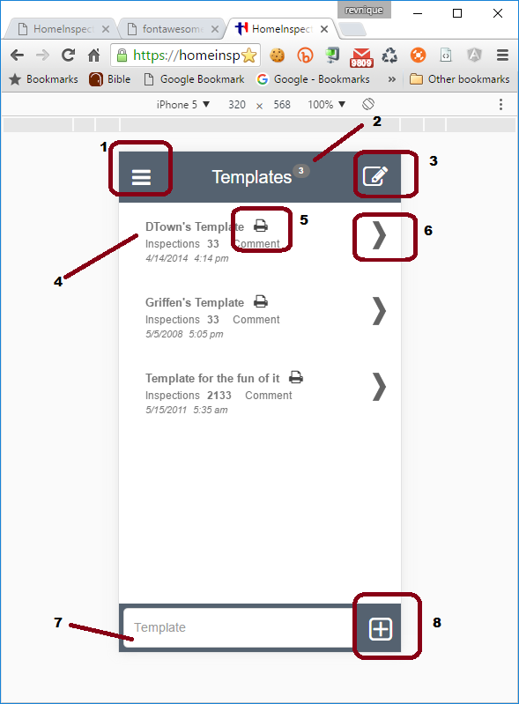

Demonstrating Css Transition for menu. Templates are the only feature coded so inspections link takes you to template. Clicking Menu will make the menu slide back out of view.

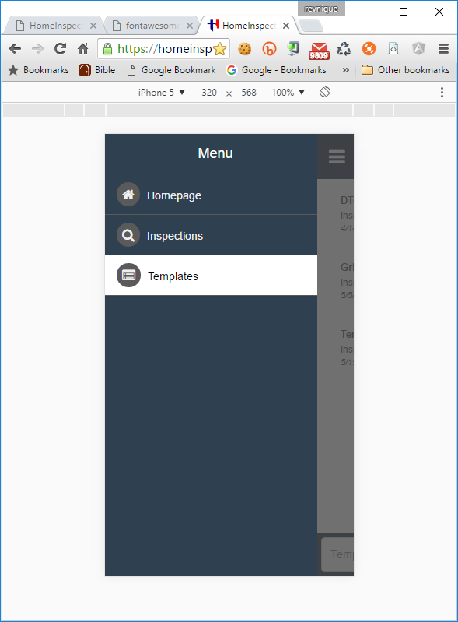

They both take you to the template screen

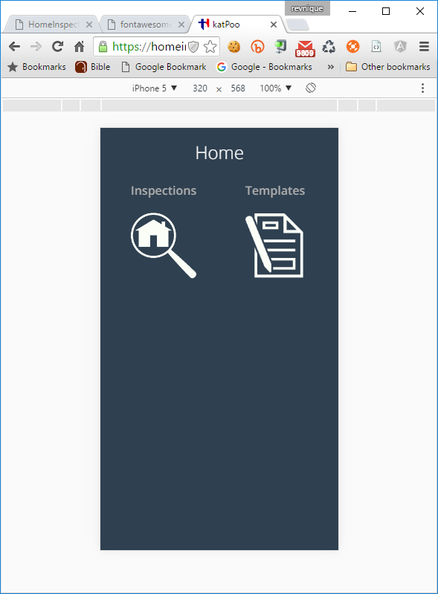

Angular JS Directive for label and textbox combined with “Enter” keypress for add item

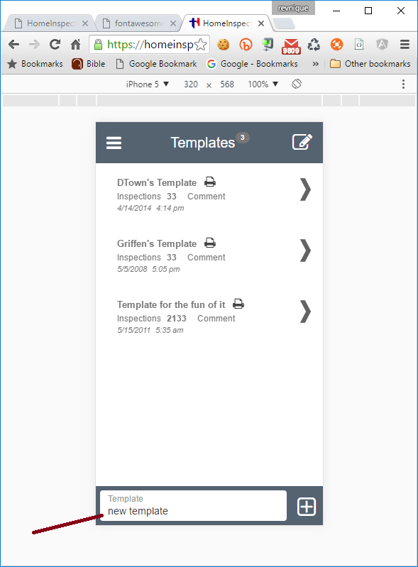

The new template was added and the count was updated

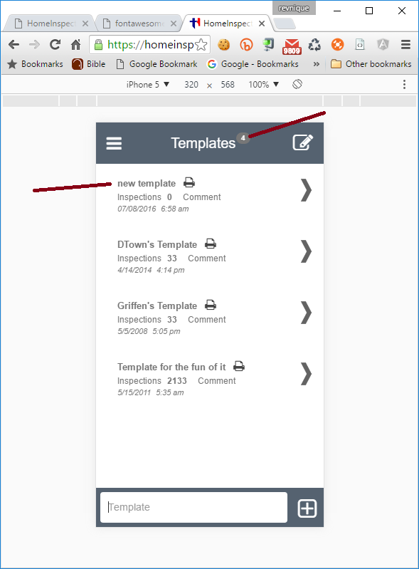

Clickable Navigation

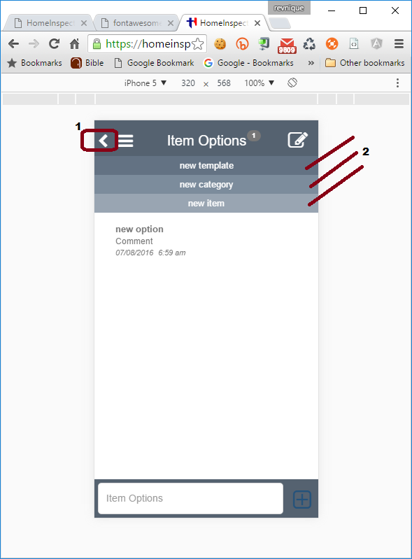

1) Navigation level name 2) Angular directive for custom label textbox

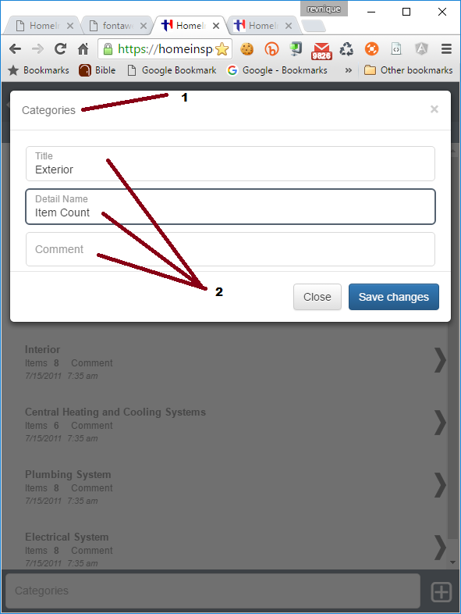

Downloaded/Printed Template PDF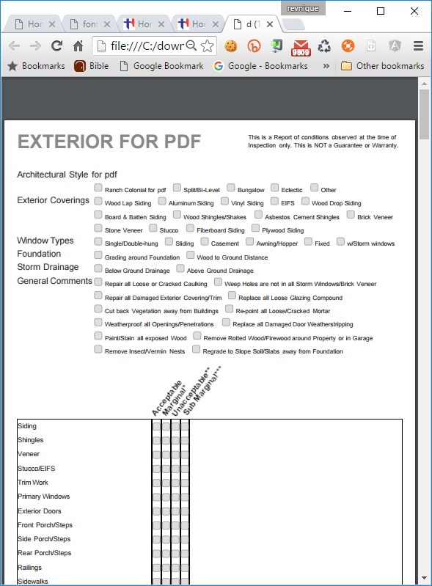

Edit Mode for list

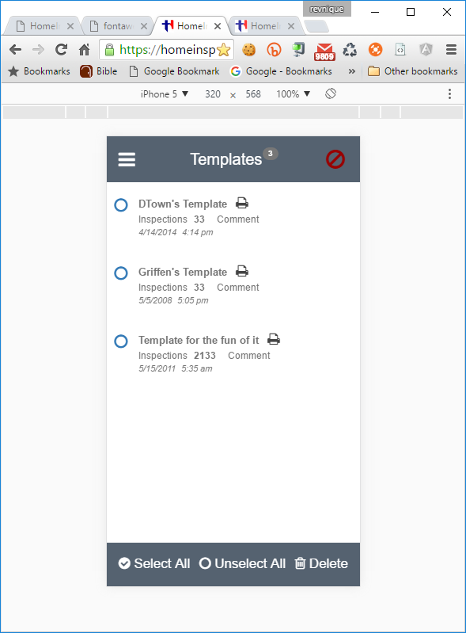

**Socket.io Demo**

Click the below link and you’ll see the push notifications.

<https://homeinspection.harristeq.com/api/socketiodemo/?m=hello%20fellas&t=this%20is%20a%20push%20demo>

SIMULTANEOUS Notifications

|  |  |
| --- | --- |
| web | iPhone  C:\downloads\IMG_4253.PNG |
| iPad  C:\downloads\IMG_0144.PNG | jsbin.com |

View Source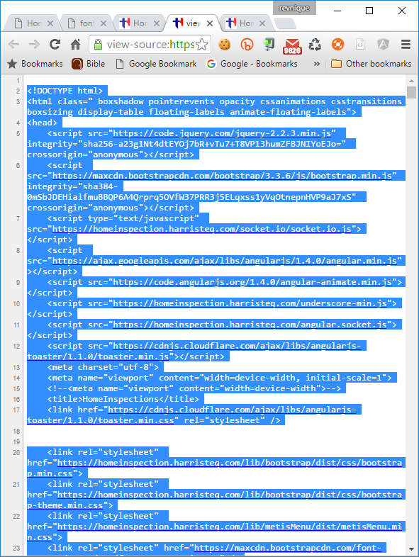

Paste source into <https://jsbin.com>

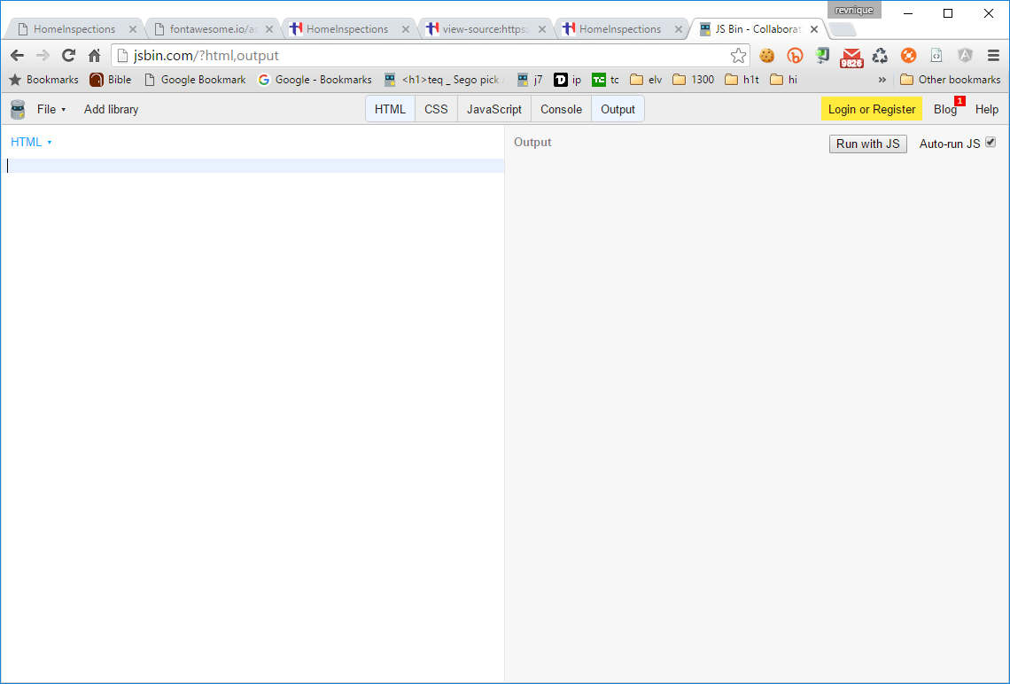

Viola!!!